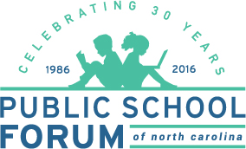
Education Matters

Education Matters is a weekly television program created by the Public School Forum to provide the public with real facts about public education in North Carolina and engage them in efforts to strengthen our schools. Each 30 minute show explores key topics in education, reviews education news headlines and recognizes education leaders in our communities.

When and Where to Watch Education Matters
Saturdays at 7:30 PM, WRAL-TV (Raleigh/Durham/Fayetteville)
Sundays at 8:30 AM, WRAZ-FOX 50 (Raleigh/Durham/Fayetteville)
Sundays at 6:30 AM, Wednesdays at 9:30 AM, UNC-TV’s North Carolina Channel (Statewide)

In addition to the show’s broadcast, full episodes are available online at both WRAL.com and ncforum.org , and promoted heavily via social media. Although just a year old, Education Matters is already making an impact. We recently received this statement in an email from a viewer:

“The very issue of education, as well as, the teaching profession, rarely receive the coverage deserved and this show is an attempt to move the issue to the forefront. Our schools, our students, our teachers, our legislators, and communities can all benefit from your efforts. As a retiree as well as fourth generation NC educator I send you my sincerest thanks. Keep up the good work.”
I appreciate that you consistently provide a space for practicing classroom teachers to share their opinions and expertise.
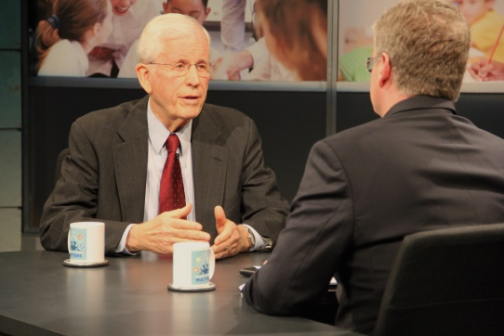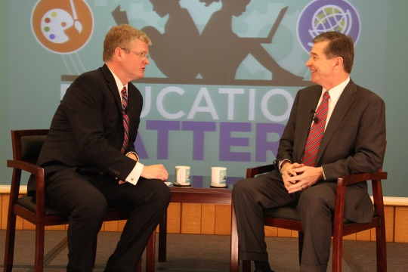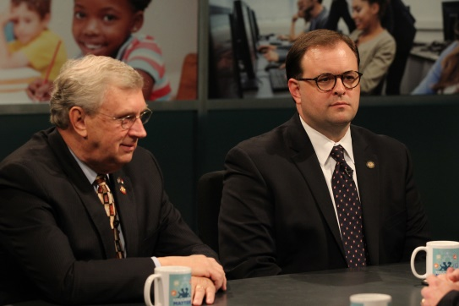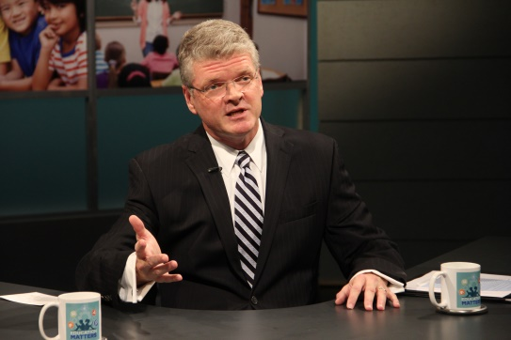
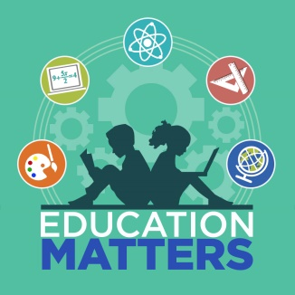

Sponsorship Information

On each episode, there are two types of sponsorship opportunities – commercials and in-show segment sponsorships. As commitments are received, sponsors and spots will be added to the show schedule.

- Approximately 7 thirty second spots will air during each show.
  - $200 per 30 second spot per episode (WRAL-TV only)
  - Spots may be purchased in any desirable amount (# of shows)

- Sponsoring the EdLines segment allow you to be featured at the beginning of each show in a section that highlights current events in public education.
  - $10,000 for a set of 10 episodes – these are shown on WRAL & UNC-TV
  - WRAL will create a custom graphic intro and voice over for each sponsor.

- Each week Leadership Spotlight recognizes education champions who are making significant contributions to their local schools.
  - $10,000 for a set of 10 episodes – these are shown on WRAL & UNC-TV
  - WRAL will create a custom graphic intro and voice over for each sponsor.

Expanding Viewership
- Premiered October 2, 2016 on WRAL-TV.

- Premiered statewide January 8, 2017 on UNC-TV’s NC Channel.

- Average rating on WRAL-TV since premiere is 1.4/16,000 Households in Raleigh market, but is trending upward. Ratings are 1/3 since we started,

- Gov. Cooper interview (1/28) was highest rated episode (2.4/28,000 HH’s) and won the time slot.

- March – April 2017 shows have nearly equaled “On the Record” numbers with average 2.2 = 24,900 HH’s, 30,600 P18+ and 7,200 P25-54.

Sponsor Commitment Form

:30 Second Spot - $200 each, air date preference: ___________________________________
My organization has a spot we would like to use.
My organization would like to work with WRAL to create spot. Please contact me.

Leadership Spotlight - $10,000 for 10 episodes, air date preference: ____________________

EdLines - $10,000 for 10 episodes, air date preference: _______________________________

Contact Information:

Name: ________________________________________________________________________

Organization: __________________________________________________________________

Organization Contact (if different): _________________________________________________

Address: ______________________________________________________________________

Phone: ________________________________Email: __________________________________

Payment Type:
Credit Card by Phone - call 919-781-6833

Check payable to: Public School Forum of North Carolina
3725 National Drive, Suite 101
Raleigh, NC 27612
Please bill me

Please send completed form to:
Keith Poston
President and Executive Director
kposton@ncforum.org
919-781-6833 ext. 105

